IOT REPORT

On

Parking system

Submitted by:Bhavana k

Internet Of Things: In a nutshell, the Internet of Things is the concept of connecting any device (so long as it has an on/off switch) to the Internet and to other connected devices. The IoT is a giant network of connected things and people – all of which collect and share data about the way they are used and about the environment around them.

Devices and objects with built in sensors are connected to an [Internet of Things platform](http://www.ibm.com/internet-of-things/), which integrates data from the different devices and applies analytics to share the most valuable information with applications built to address specific needs.

Smart Parking System:

Smart parking development implies an IoT-based system that sends data about free and occupied parking places via web/mobile application. The IoT-device, including sensors and microcontrollers, is located in each parking place. The user receives a live update about the availability of all parking places

IDEA: Parking slots are monitored using IR sensors which detects whether there is a car or not at the slot through infrared rays. The camera also captures the picture of parked car.

The information is sent to the cloud and stored in Iot device and also updated at the user interface.

The picture is stored in the cloudant object storage and text information is stored in the database of cloud

Buttons are provided in interface to indicated whether they are parking in or out.

These idea is implemented as follows.

1.The IoT device is created in the ibm cloud to store the sensor inputs and connect the cloud with the sensor.It contains certain device credential which can help in accessing the device through python code. The device looks as follows.

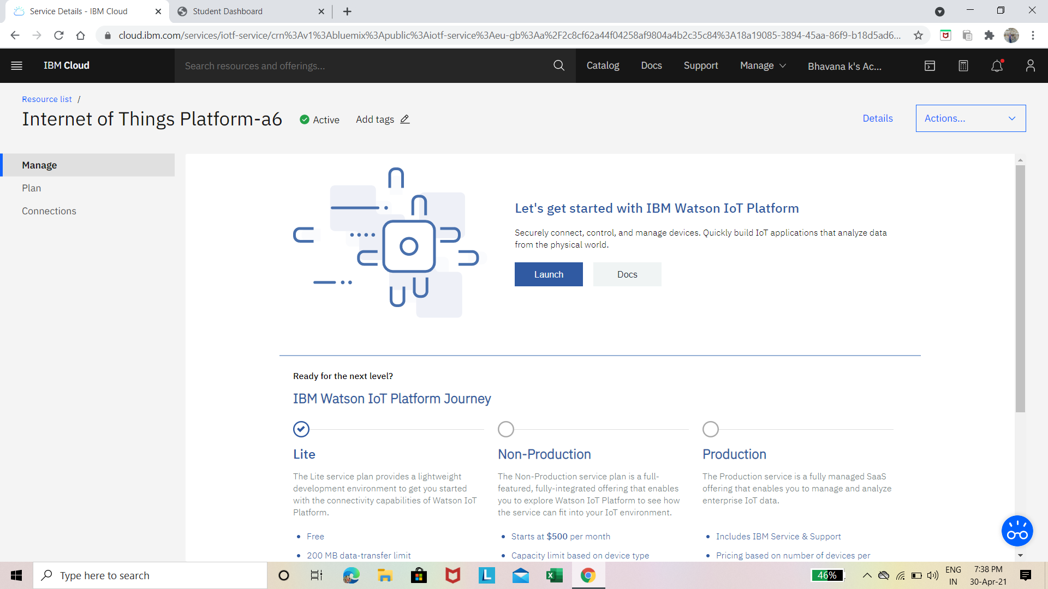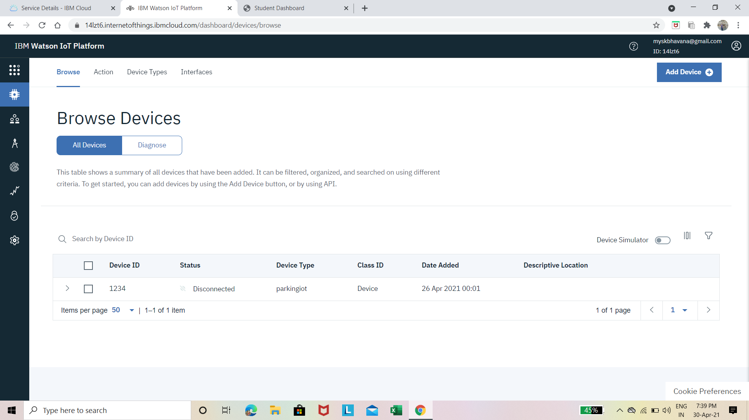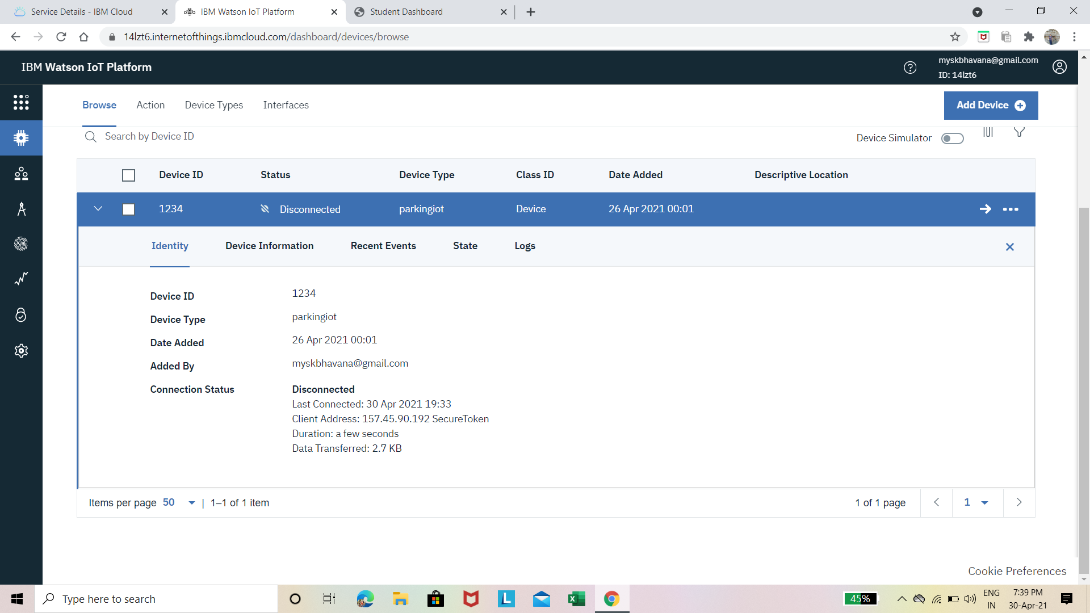

2.After Iot device creation we need a user interface to set up for user to interact with the parking system

This is achieved through node-red service of ibm cloud which works on Json code and helps us create a user interface through nodes provided the nodes are as follows.

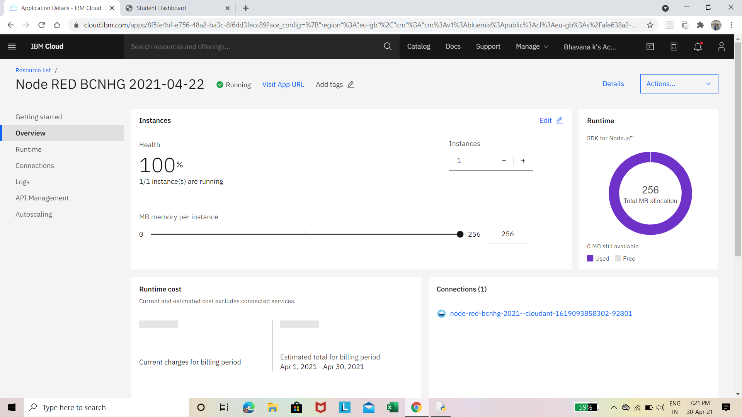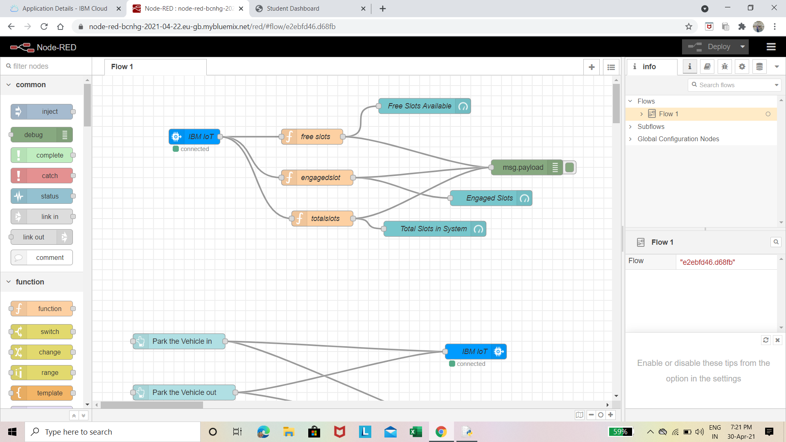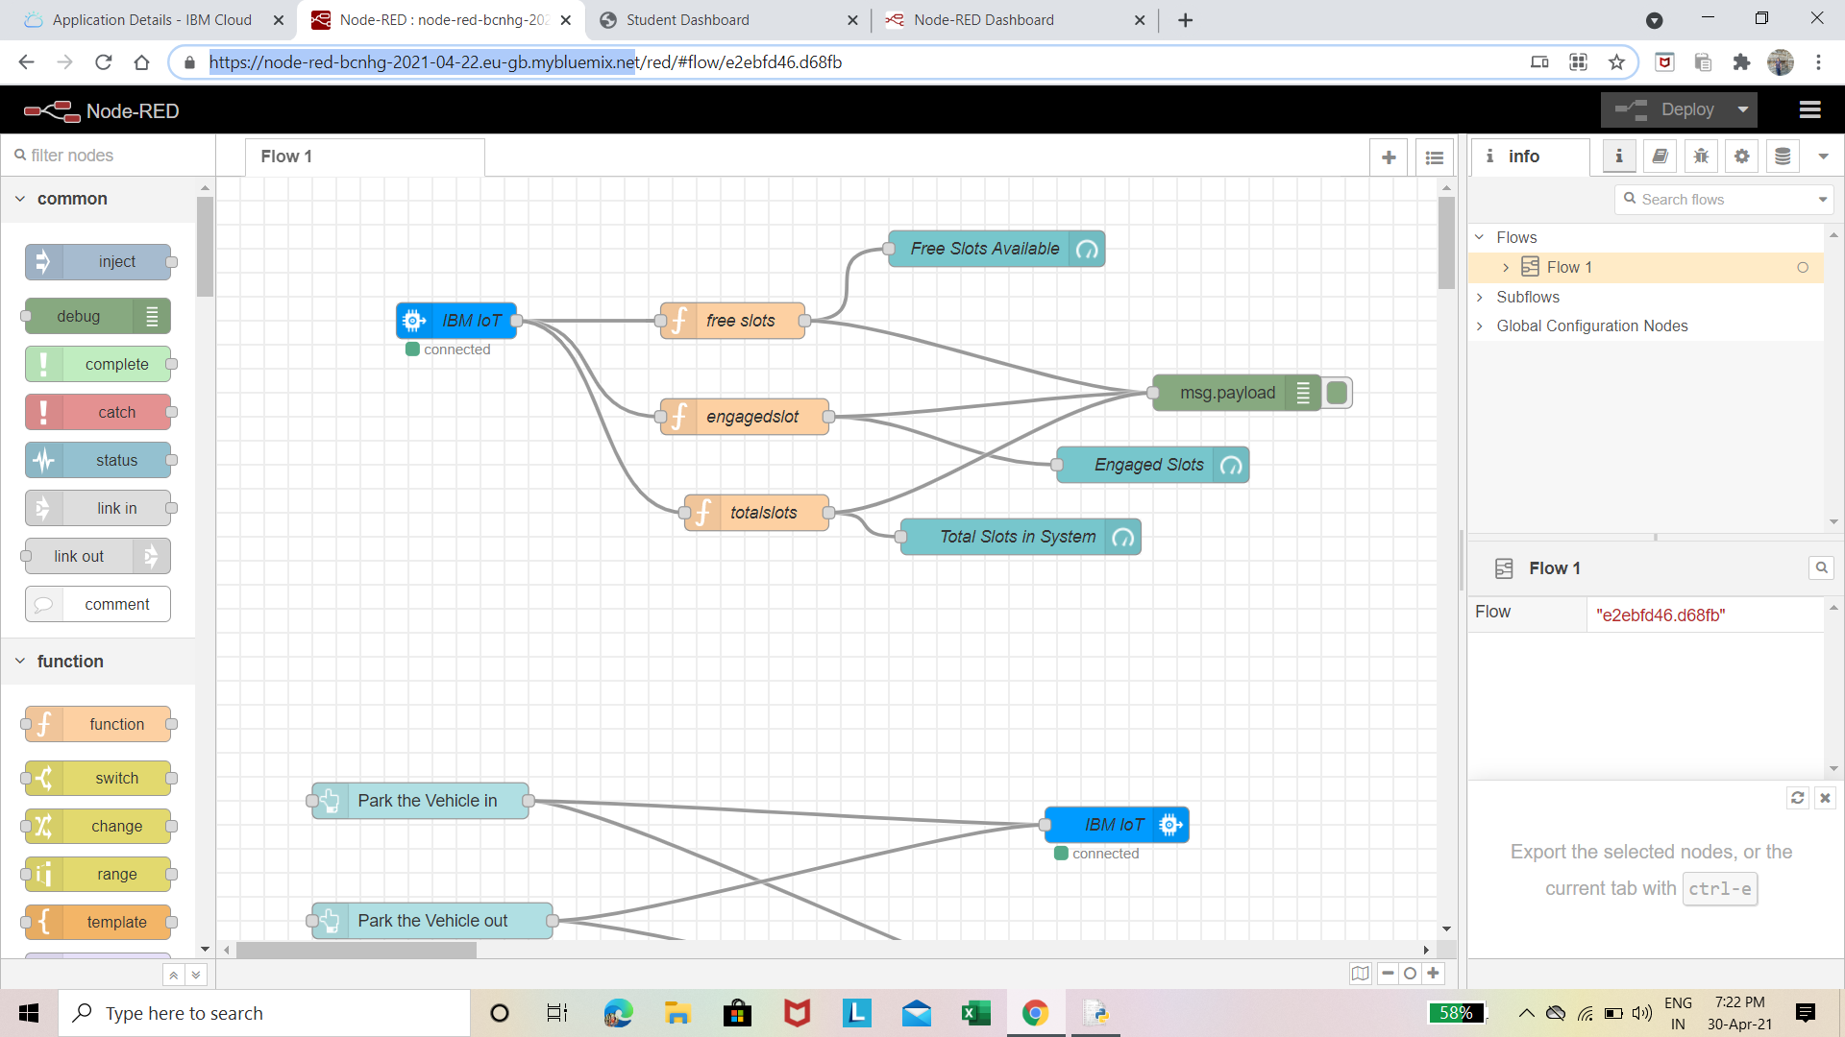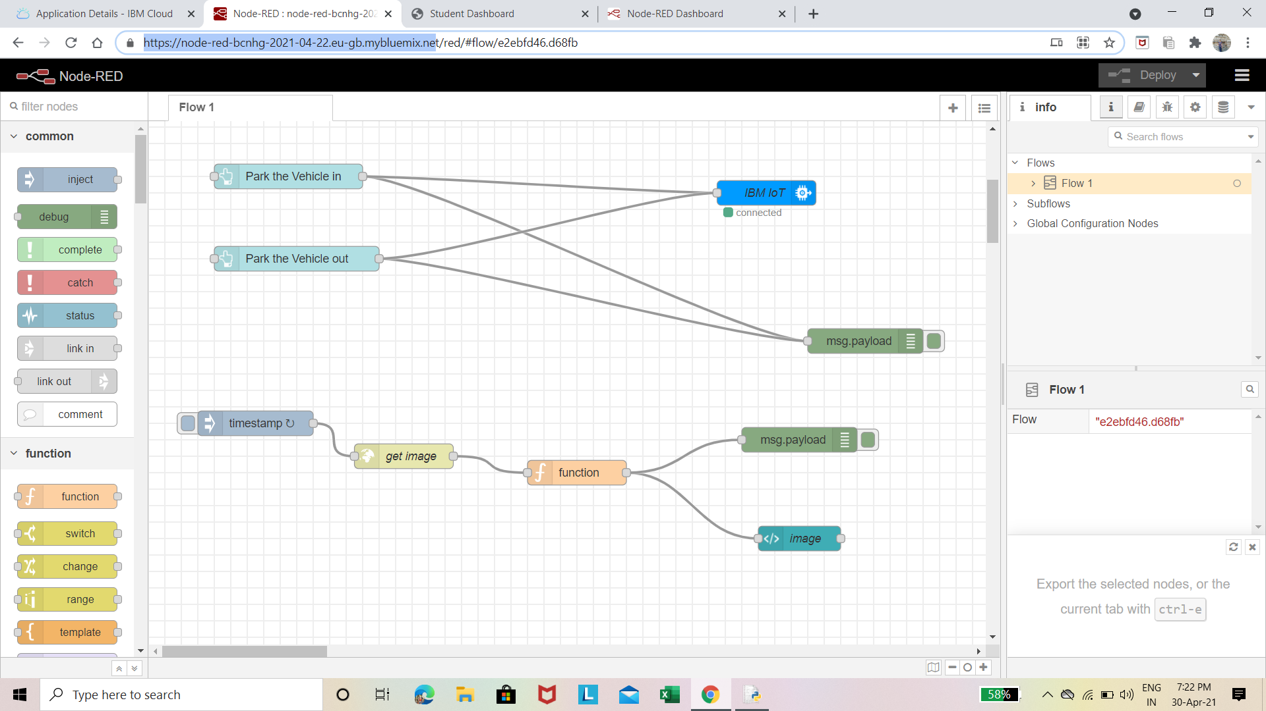

These below pictures are the user interface pictures which is created through the nodes.

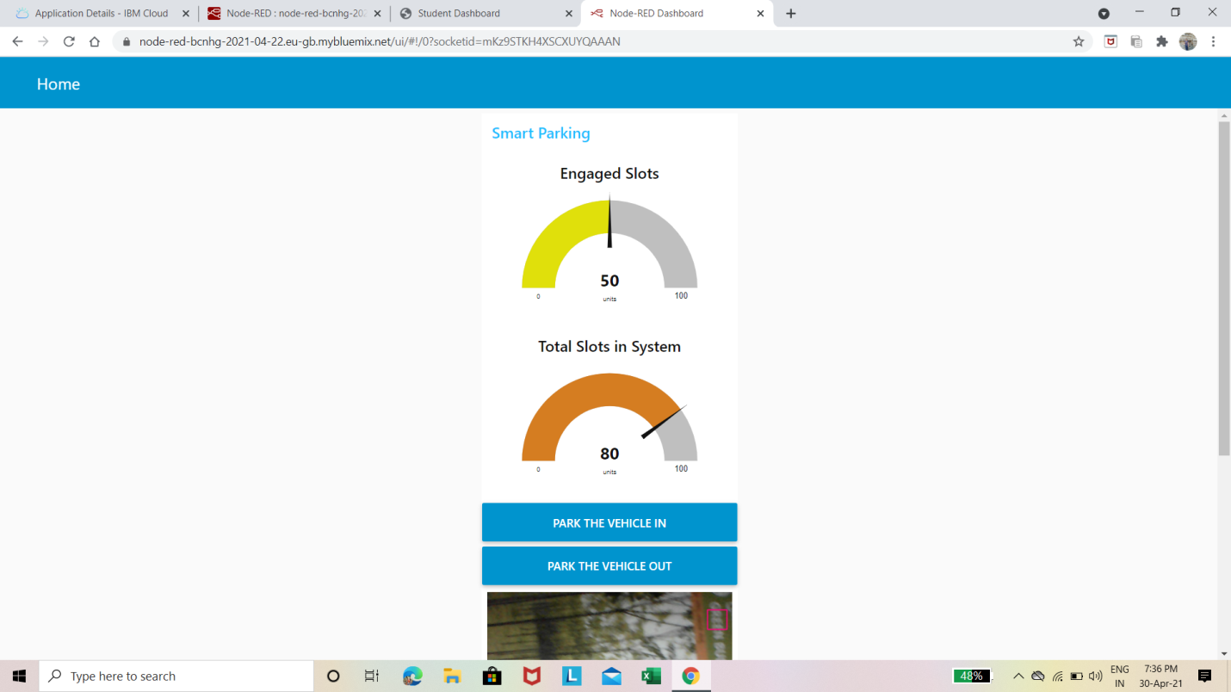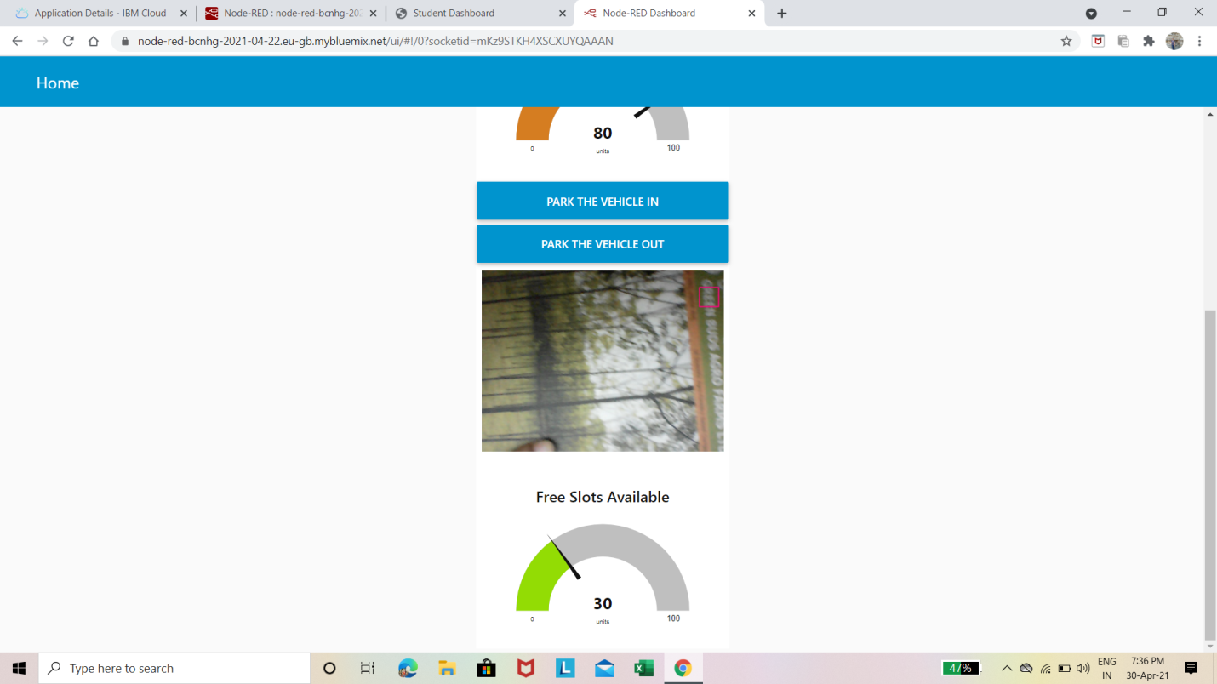

3.The pictures are stored are in the cloudant object storage which is retrieved through some public url.

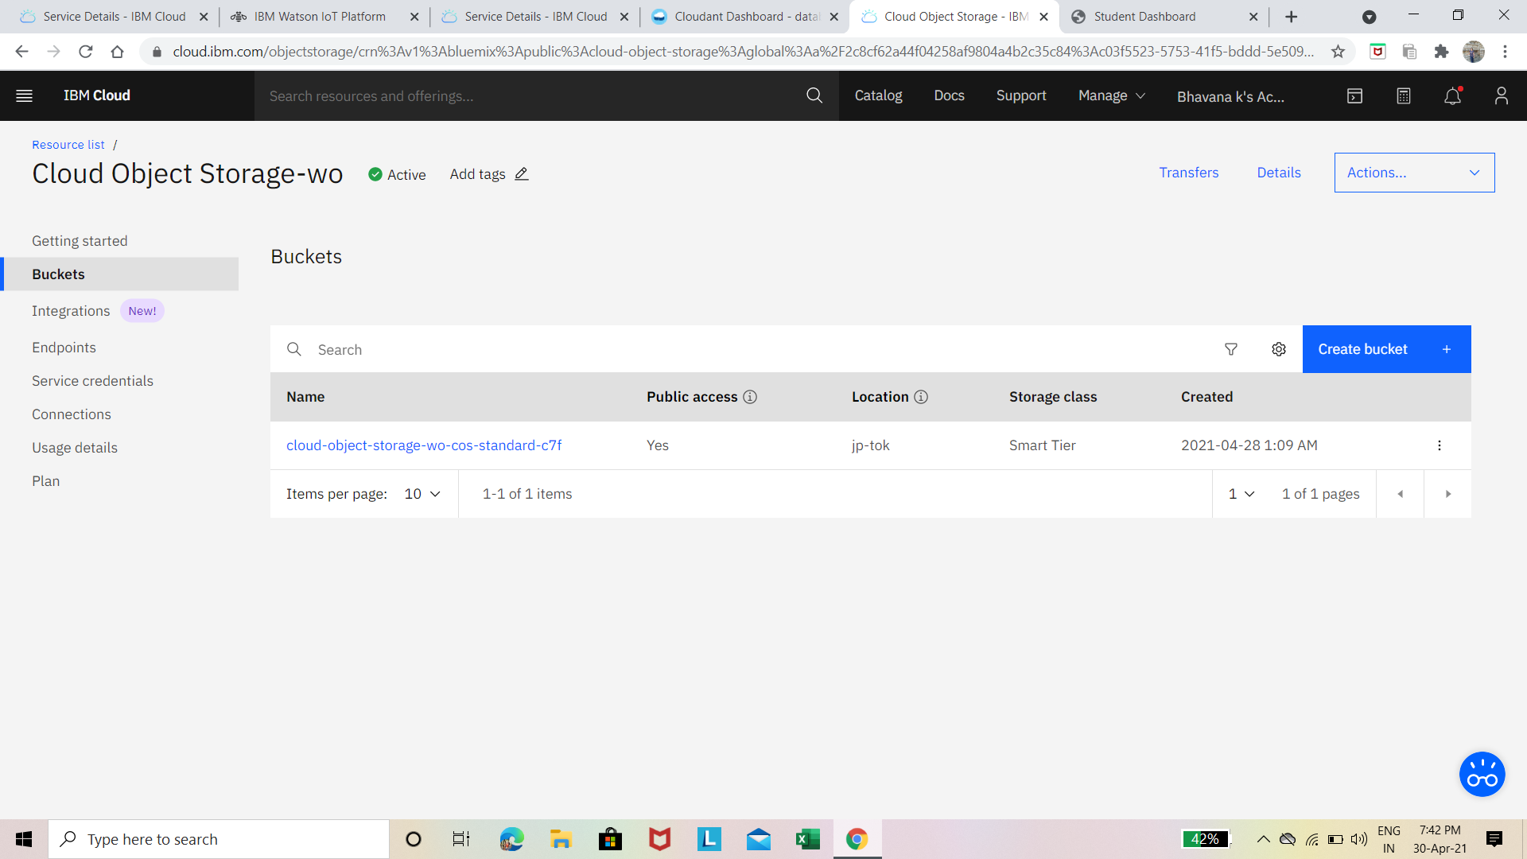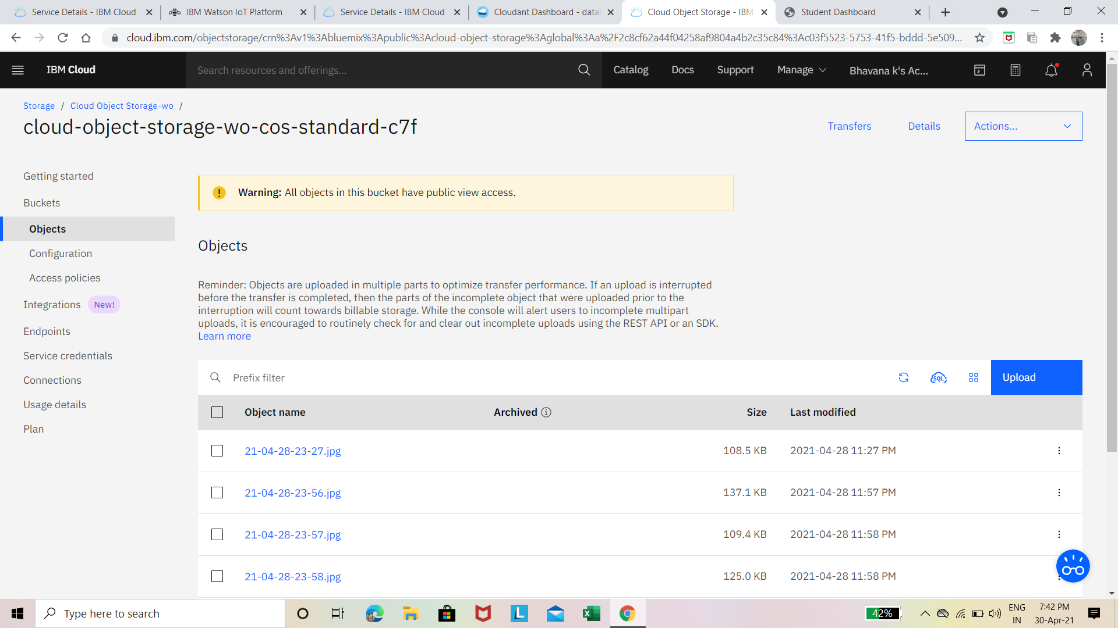

4.The node-red has a database which stores the text data which is sent to it the pictures link is stored in database which can be retrieved.

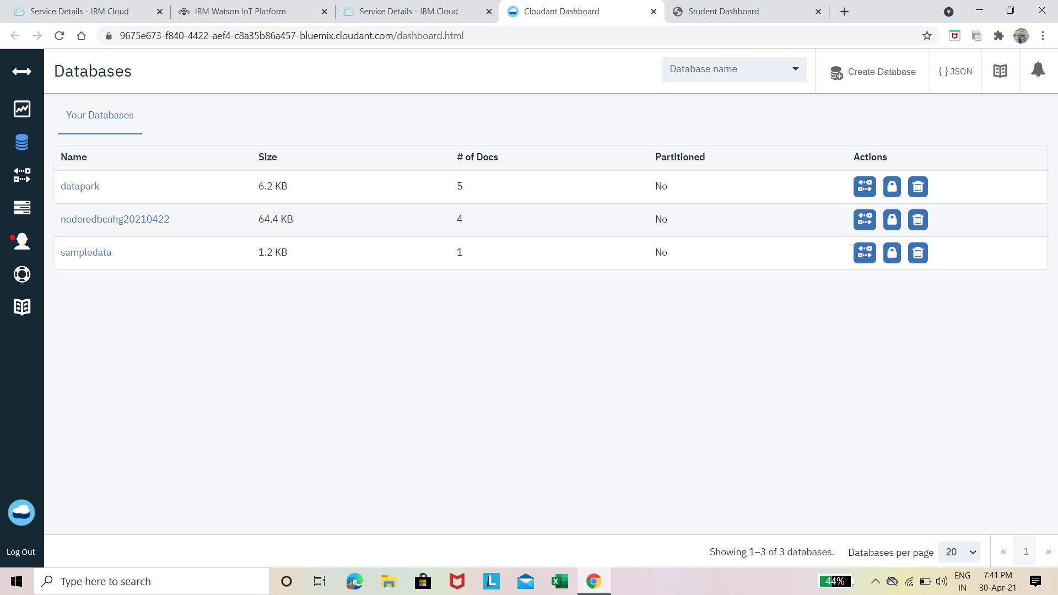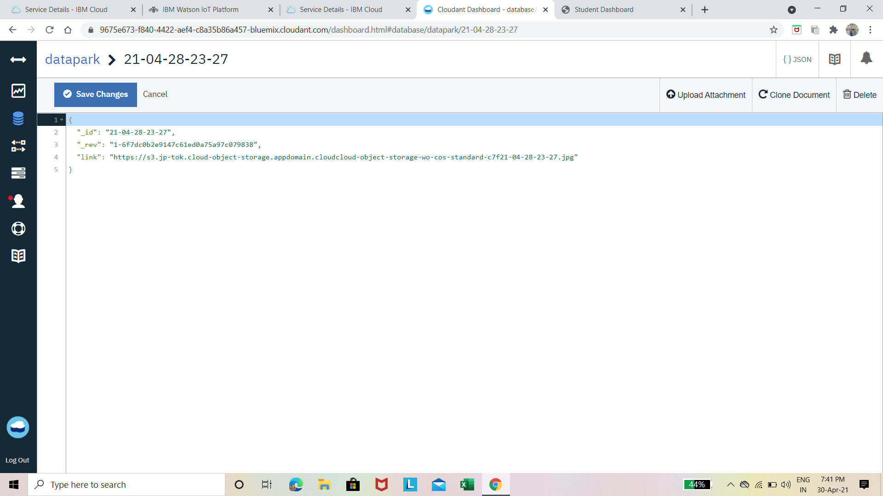

5.All the data are sent through python code by connecting the devices with certain device credentials,endpoints,username and password,and the camera is used for live video streaming which shows the slots whether filled or empty.

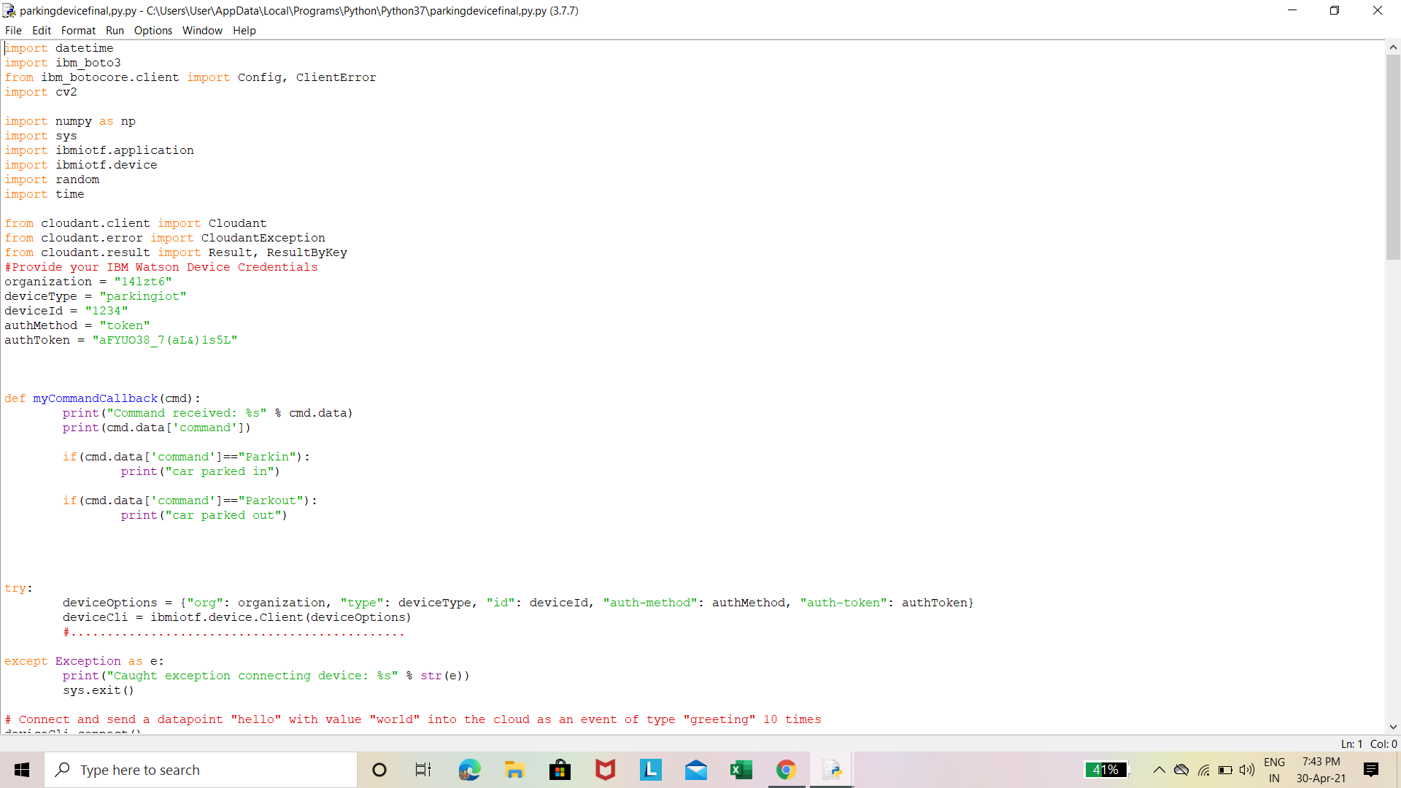

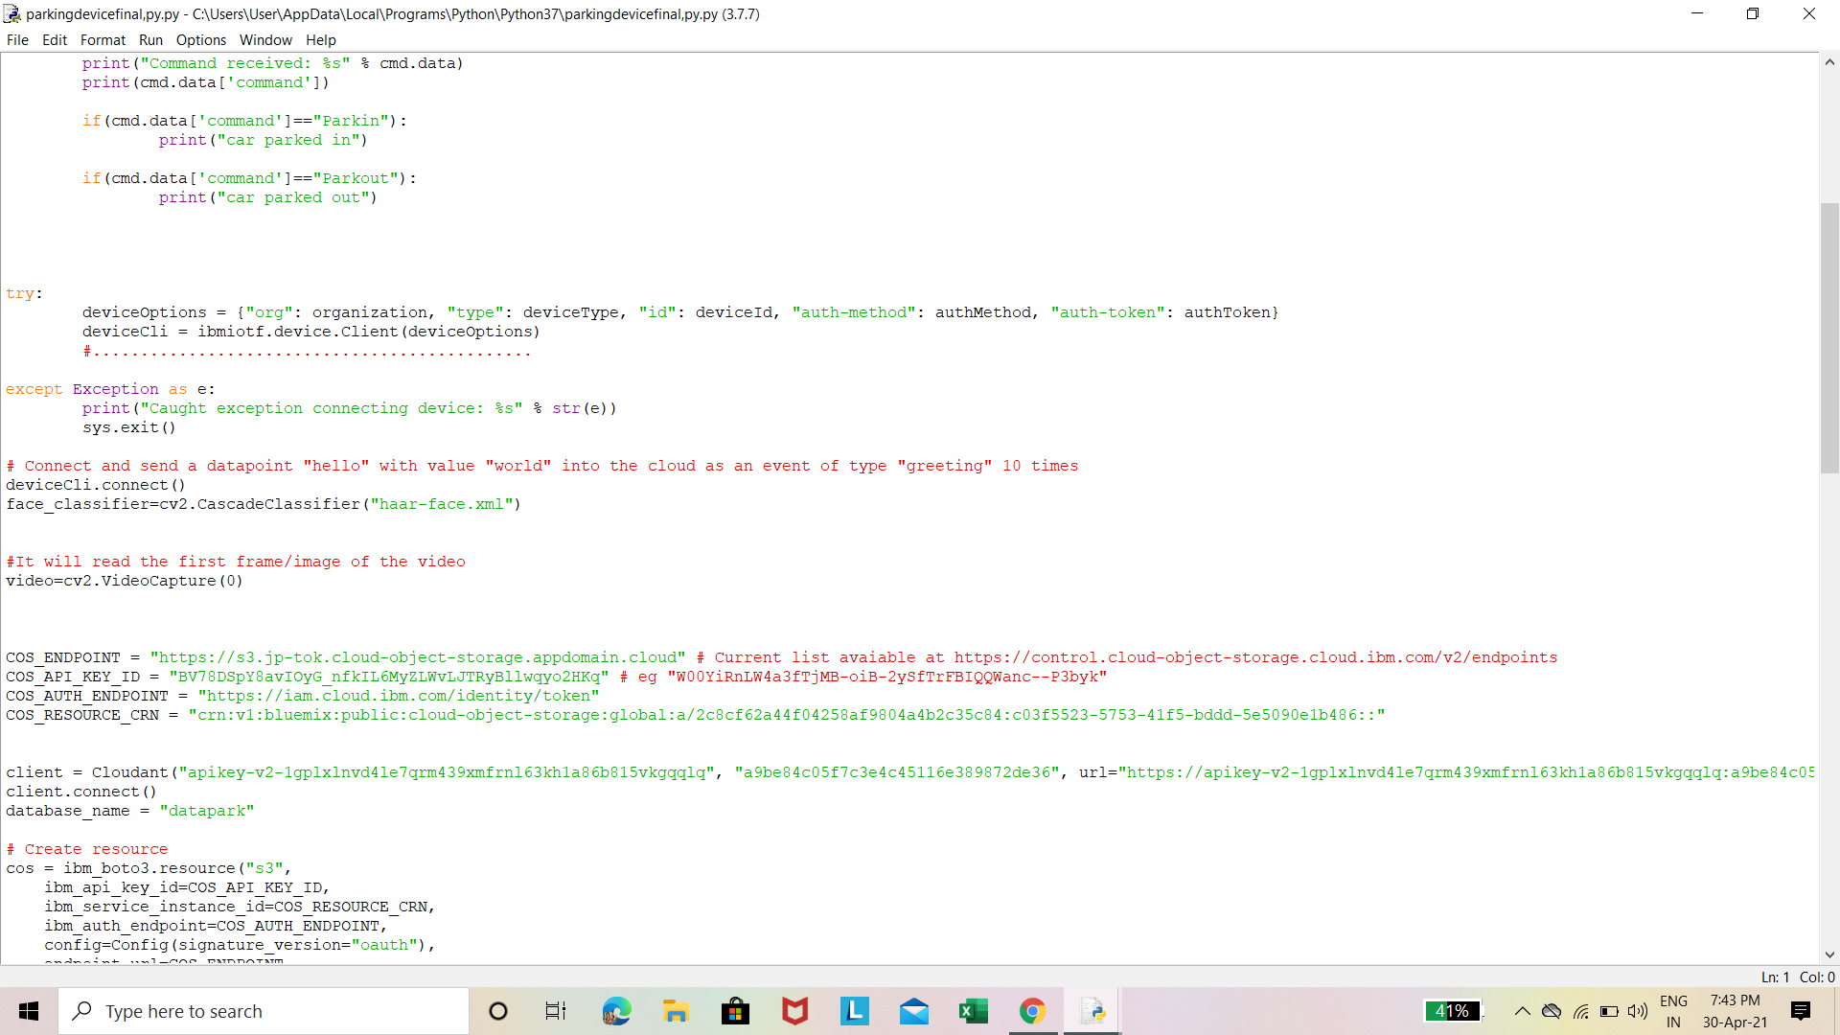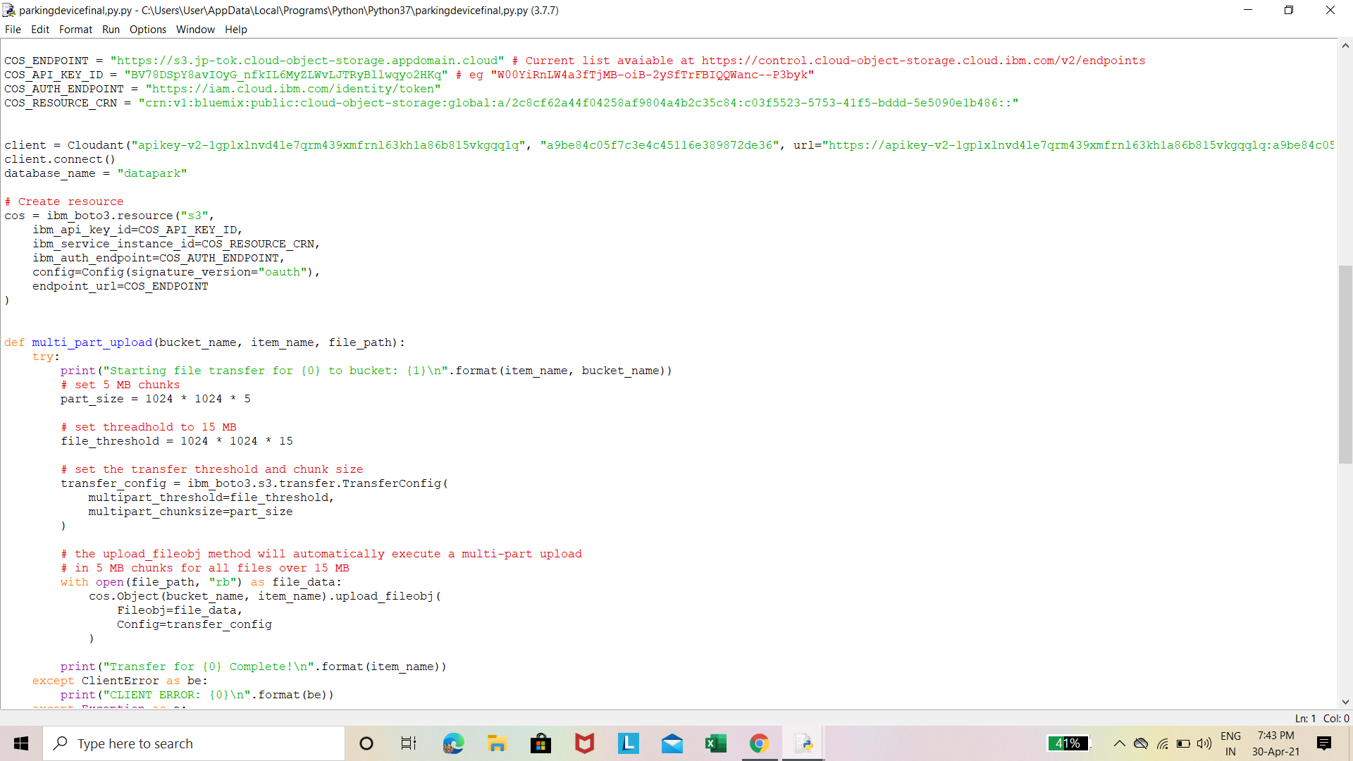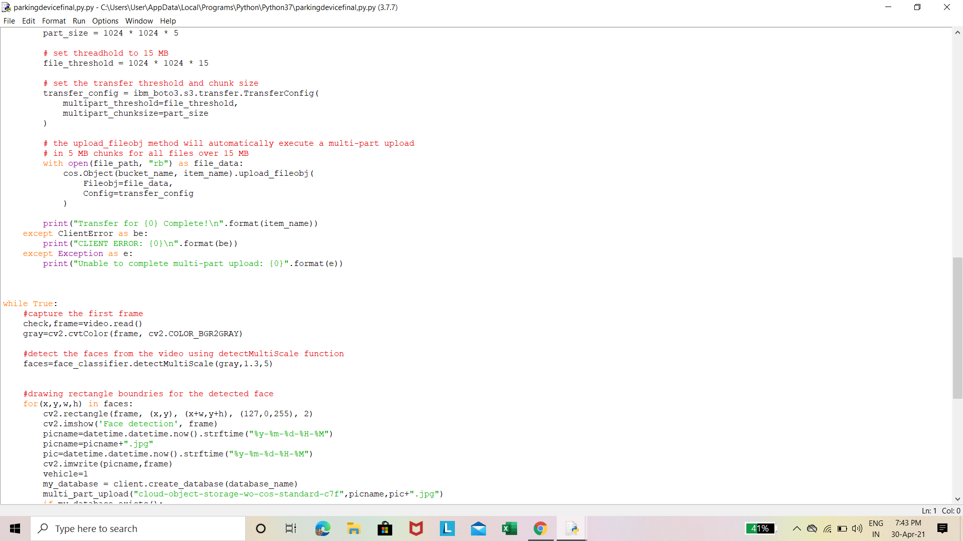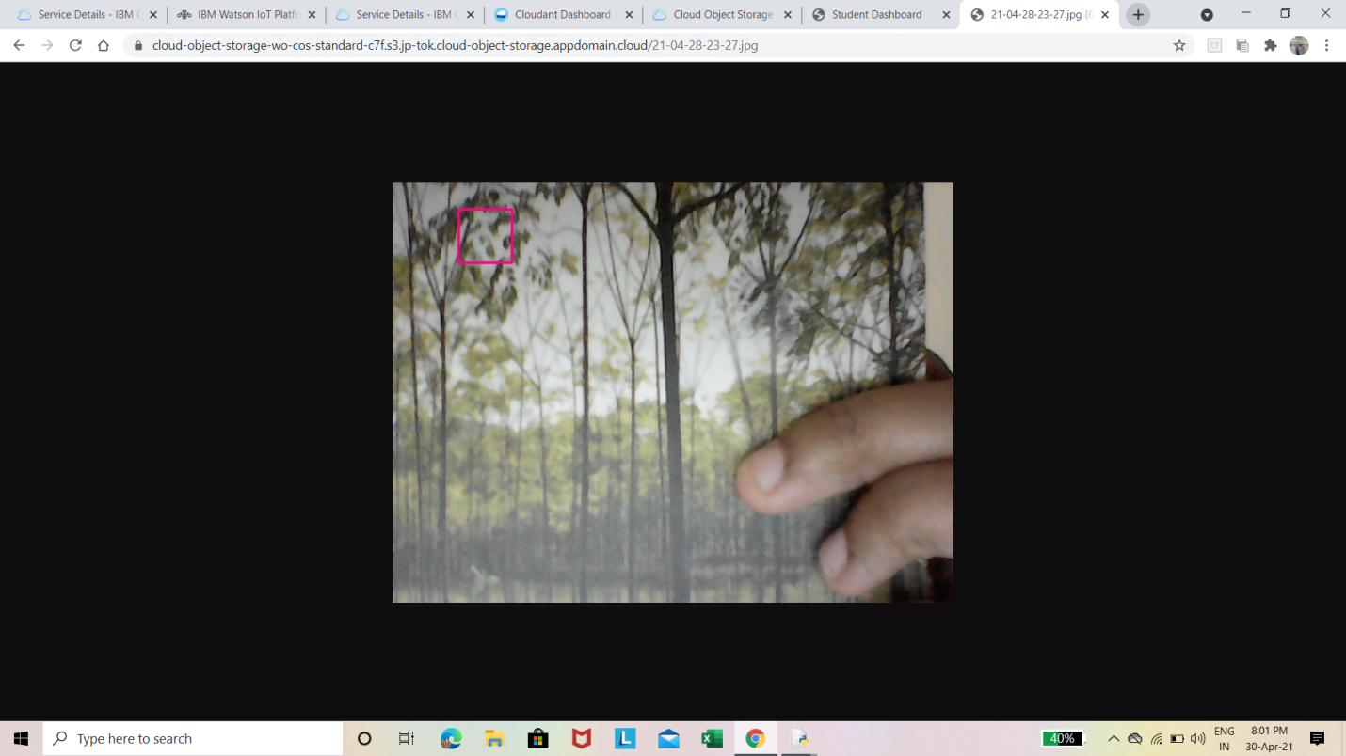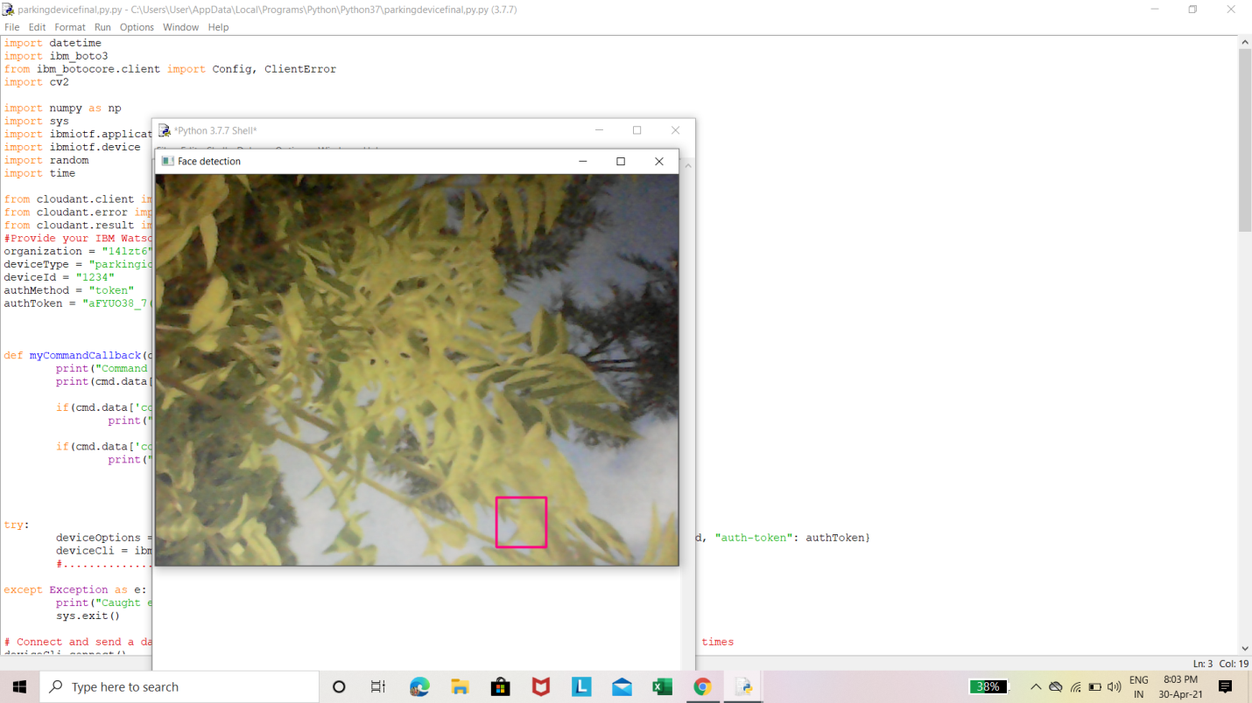

Live video streaming picture.

These steps help us setup a smart Parking System and the gauge in UI shows the free slots to the user.

**Link for the demo video:**

<https://drive.google.com/file/d/1VsxXVoPZ6E5dnhT3EfuM7oTjtTS0CPXZ/view?usp=sharing>